

BUSINESS BLUEPRINT

Document information
Project Name | VinaTech Smart Manufacturing's order status management system
Module | FI – Financial Accounting
Sub-Module | GL – General Ledger
Created by | DucNM, DatNV
Version | 1.0
Date

Table of Contents

1 OVERVIEW 4
1.1 Scope 4
1.2 Glossary 4
1.3 Flow chart shapes usage 4
1.4 Document Naming Convention 5
2 Organizational Structure 6
2.1 Company Code 6
2.2 Business Area 6
2.3 Credit Control Area 7
2.4 Basic Setting 7
2.4.1 Fiscal Year Variant 7
Cal. Year, 12 Special Period 7
2.4.2 Posting Period Variant 7
2.4.3 Currencies and Exchange rate maintenance 7
2.4.4 Controlling currency (CO) 8
2.4.5 Document Types 8
2.4.6 Tax Reporting 9
3 Master Data 10
3.1 Chart of Accounts 10
3.2 General Ledger Accounts Master Data 10
3.2.1 G/L Account Group 10
3.2.2 Reconciliation Accounts 10
3.2.3 Open Item Accounts 11
3.2.4 FI – GL Retained Earning Account 11
3.2.5 FI – GL SD Account Determination 11
3.2.6 FI – GL MM Account Determination 11
3.2.7 FI – GL Tax Account Determination 12
3.2.8 Functional Areas 12
3.3 Bank master data and house bank 12
4 Business Processes 13
4.1 SD-FI-BP-01 : Order to G/L Posting Process 14
4.2 SD-FI-BP-02 : Order Status Tracking & G/L Posting 16

OVERVIEW

Scope
This document describes the configuration and business processes of FI-GL (General Ledger) in SAP S/4HANA for VinaTech Smart Manufacturing.
- The scope includes:
- Organizational structure related to FI
- Chart of Accounts configuration
- G/L account master data
- Account determination
- Tax configuration
- G/L posting process
- Financial reporting

Glossary
Term | Definition | Note
FI | Financial
GL | General Ledger
COA | Chart of Accounts
AR | Accounts Receivable
AP | Accounts Payable
VAT | Value Added Tax
PGI | Post Goods Issue

Flow chart shapes usage
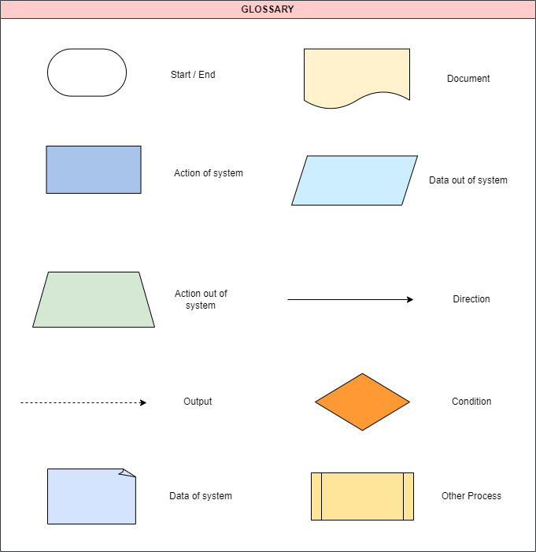

Document Naming Convention
Process Code has 8 characters : <AA>. <BB>. <CC>. <DD>
- AA : is a character, describing 2 first characters of the module.
- BB : MD for processes which relate to Master Data or BP for business process.
- CC : is a character, describing 2 first character of the sub-module.
- DD : is a number from 01 to 99 describing quantity.

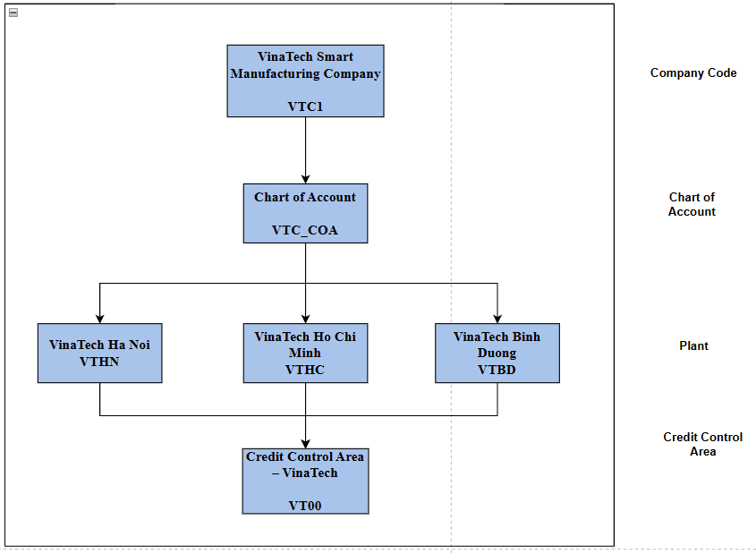
Organizational Structure

Company Code
Implementing SAP S/4HANA Finance for VinaTech Smart Manufacturing Company, whose head office is located in Hanoi.
Set up Company Code (VTC1) represents an independent legal accounting entity with independent financial statements and reporting structure.
Company Code | Description
VTC1 | VinaTech Smart Manufacturing Company

Plant
An organizational unit where materials are produced, stored, and managed.
For VinaTech Smart Manufacturing, business areas are defined according to geographical operations:

Plant | Description
VTHN | VinaTech Ha Noi
VTHC | VinaTech Ho Chi Minh
VTBD | VinaTech Binh Duong

Credit Control Area
Credit Control Area | Description | Currency | Update | FY Variant
VT00 | VinaTech Credit Control | VND | 00012 | K4

Basic Setting

Fiscal Year Variant
Fiscal Year Variant | Description
K4 | Calendar Year, 12 Posting Periods

Posting Period Variant
Posting Period Variant | Description
VT00 | VinaTech Posting Period

Currencies and Exchange rate maintenance
Currencies and Exchange rate maintenance | Description
VND | Vietnam Dong

Document Types
Doc. Types | Description | Number range | Reverse Doc Type | Assets | Customer | Material | G/L acc.
SA | G/L Account Posting | 01 | AB | X | X | X | X
AB | Accounting Document | 01 | AB | X | X | X | X
DR | Customer Invoice | 18 | DA | X | X | X | X
DG | Customer Credit Memo | 17 | DA | X | X | X | X
D2 | Customer Payment | 00 | DA |  | X |  | X

Tax Reporting

VAT Tax

No | Tax code | Description | Country key | Procedure | Tax Type | Tax rate (%) | Account Key
1 | I1 | Input Tax Deduction 10% | VN | TAXVN | V (Input tax) | 10 | VST
2 | A1 | Output Tax 10% | VN | TAXVN | A (Output tax) | 10 | MWS
3 | I2 | Input Tax Deduction 8% | VN | TAXVN | V (Input tax) | 8 | VST
4 | A2 | Output Tax 8% | VN | TAXVN | A (Output tax) | 8 | MWS
5 | I3 | Input Tax Deduction5% | VN | TAXVN | V (Input tax) | 5 | VST
6 | A3 | Output Tax 5% | VN | TAXVN | A (Output tax) | 5 | MWS
7 | I4 | No Tax | VN | TAXVN | V (Input tax) | 0 | VST
8 | A4 | No Tax | VN | TAXVN | A (Output tax) | 0 | MWS

Master Data

Chart of Accounts
COA | Description | Language
VT00 | VinaTech Chart of Accounts | English

General Ledger Accounts Master Data

G/L Account Group
A chart of accounts (VT00) contains different types of accounts and these accounts are arranged into account groups.
By assigning number ranges to each account group, accounts of similar nature are controlled within defined intervals.
COA | G/L Account Group | Name | From Account | To Account
VT00 | AR | Customer Receivables | 131000 | 131999
 | AST | Assets | 100000 | 199999
 | COGS | Cost of Goods Sold | 632000 | 632999
 | EQT | Equity / Retained Earnings | 421000 | 421999
 | INV | Finished Goods Inventory | 156000 | 156999
 | REV | Sales Revenue | 511000 | 511999
 | TAX | VAT Output Tax | 333100 | 333199

Reconciliation Accounts

G/L Account | Name
131000 | Account Receivable
331000 | Account Payable
100000 | Assets

Open Item Accounts
Open Item Management is activated for accounts that require clearing against related transactions.
Open item management is used to:
- Track outstanding receivables and payables
- Monitor bank clearing transactions
- Ensure proper reconciliation

FI – GL Retained Earning Account
G/L Account | G/L Account Name
421000 | Equity / Retained Earnings

FI – GL SD Account Determination
Revenue accounts | Name
131000 | Customer Receivables
511000 | VTC Sales Revenue
333100 | VTC VAT Output Tax

FI – GL MM Account Determination
Expense accounts | Name
156000 | VTC Finished Goods Inventory

FI – GL Tax Account Determination
Account Key | Tax code | G/L Account | G/L Account Name
VST | I1 | 133110 | Input VAT 10%
MWS | A1 | 333110 | Output VAT 10%
VST | I2 | 133110 | Input VAT 8%
MWS | A2 | 333110 | Output VAT 8%
VST | I3 | 133110 | Input VAT 5%
MWS | A3 | 333110 | Output VAT 5%
VST | I4 | 133110 | No Tax
MWS | A4 | 333110 | No Tax

Functional Areas
Functional Area | Description
YB40 | Administration
YB20 | Production
YB10 | Sales Revenue
YB15 | Sales Deduction

Bank master data and house bank
The company defines one main house bank for receiving and making payments.
House Bank | Account ID | Bank Account | Currency | Purpose | G/L Account Main-Bank
VTB1 | VND01 | 1010908071 | VND | Receive customer payments and vendor payments | 112000

Business Processes

SD-FI-BP-01 : Order to G/L Posting Process
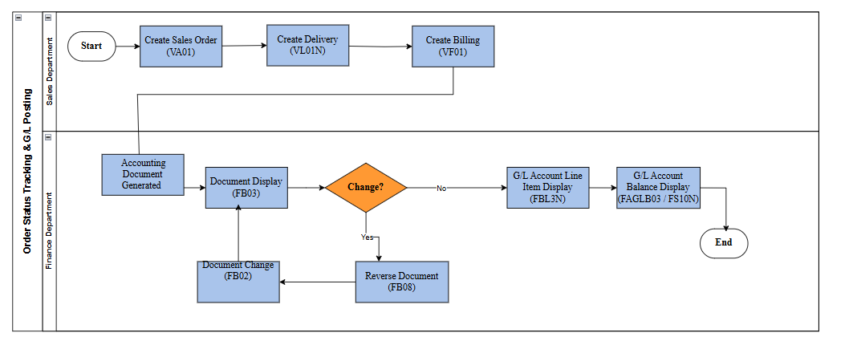
Business flow process :

Process Description:
Step | Step Name | Detailed Description | Role
1 | Requirement of creating Sales Order | Input: Customer purchase request  Explain: Sales department reviews customer order before creating Sales Order  Output: Sales Order request is approved | Sales Department
2 | Create Sales Order | Input: Customer data, material, quantity  Explain: Sales Order is created in SAP system (VA01) | Sales Department
3 | Check Stock Availability | Input: Material & quantity  Explain: System performs ATP check to ensure stock availability | System
4 | Create Delivery | Input: Confirmed Sales Order  Explain: Outbound delivery document is created (VL01N) | Logistics Department
5 | Post Goods Issue | Input: Delivery document  Explain: Inventory is reduced and COGS is posted automatically | System
6 | Create Billing | Input: Delivery document  Explain: Billing document is created (VF01) | Sales Department
7 | Accounting Posting | Input: Billing document  Explain: Accounting document is automatically generated in FI | Finance Department
8 | G/L Update | Explain: Revenue, VAT and Accounts Receivable are updated in General Ledger | Finance Department

SD-FI-BP-02 : Order Status Tracking & G/L Posting
Business flow process :

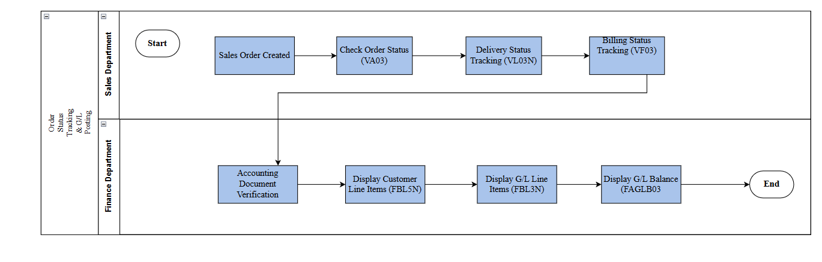

Process Description:
Step | Step Name | Detailed Description | Role
1 | Requirement of creating Sales Order | Input: Request Create G/L Posting Transactions  Explain: An authorized person reviews G/L Posting Transactions requests before initiating the return process.  Output: Request is approved | Request Department
2 | Create Sales Order | Input: Information about G/L transaction  Explain: recording financial transactions in the G/L accounts  Output: G/L transaction | Finance Department
3 | Post Goods Issue | Input: G/L transaction  Explain: view details of a G/L transaction document that has been posted in the system.  If needing to change, switch step 4.1 and 4.2  If there is no information needs to be changed, switch step 5 | Finance Department
4 | Create Billing | Input: G/L transaction  Explain: Reversing documents containing incorrect information cannot be changed | Finance Department
5 | Accounting Posting | Input: G/L transaction in the system  Explain: Update or correct incorrect information in posted documents | Finance Department
6 | G/L Document Display | Input: G/L Account Line Item  Explain: Review detailed transaction data, verify postings, perform reconciliations,... | Finance Department
7 | G/L Account Balance Display | Input: G/L Account Balance  Explain: View the summary of balances for G/L accounts such as opening balances, debits, credits,... | Finance Department

